Kubernetes Task-02
- Create a Simple Pod Using YAML Task: Write a YAML file to create a Pod named firstpod with an nginx container. Verify the Pod creation using kubectl get pods and check the logs of the container using kubectl logs firstpod.
  - Create YAML File
Create a file named firstpod.yaml



apiVersion: v1
kind: Pod
metadata:
name: firstpod
spec:
containers:
- name: nginx-container
image: nginx
ports:
- containerPort: 80

  - Create the Pod
Run this command:
kubectl apply -f firstpod.yaml

  - Verify Pod Creation
kubectl get pods
Expected output:
NAME READY STATUS RESTARTS AGE
firstpod 1/1 Running 0 10s

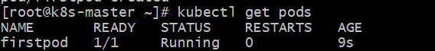

  - Check Pod Details (Optional)
kubectl describe pod firstpod
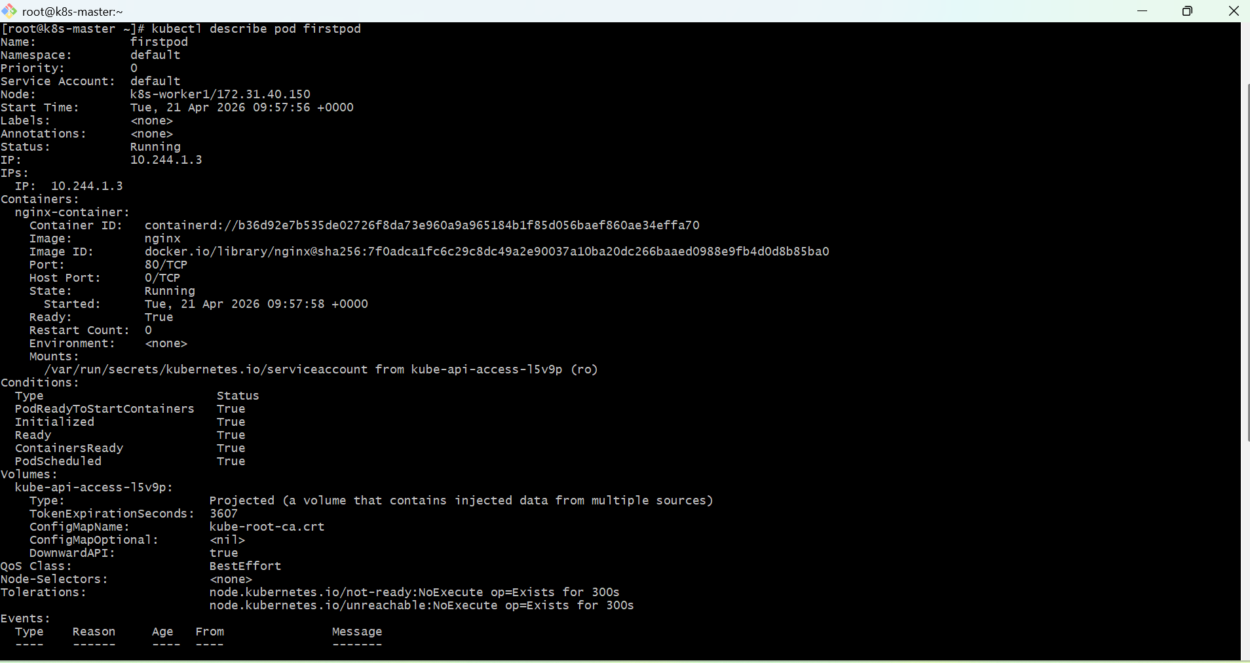

  - Check Container Logs
kubectl logs firstpod
For nginx, logs may show access logs or startup info.

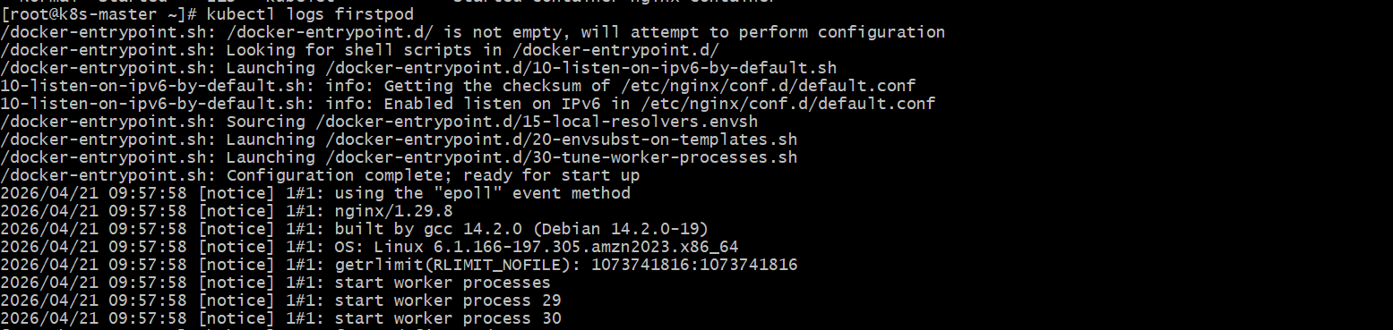

  - Test Pod (Optional)
Port forward to access nginx:
kubectl port-forward firstpod 8080:80
Now open browser:
http://localhost:8080
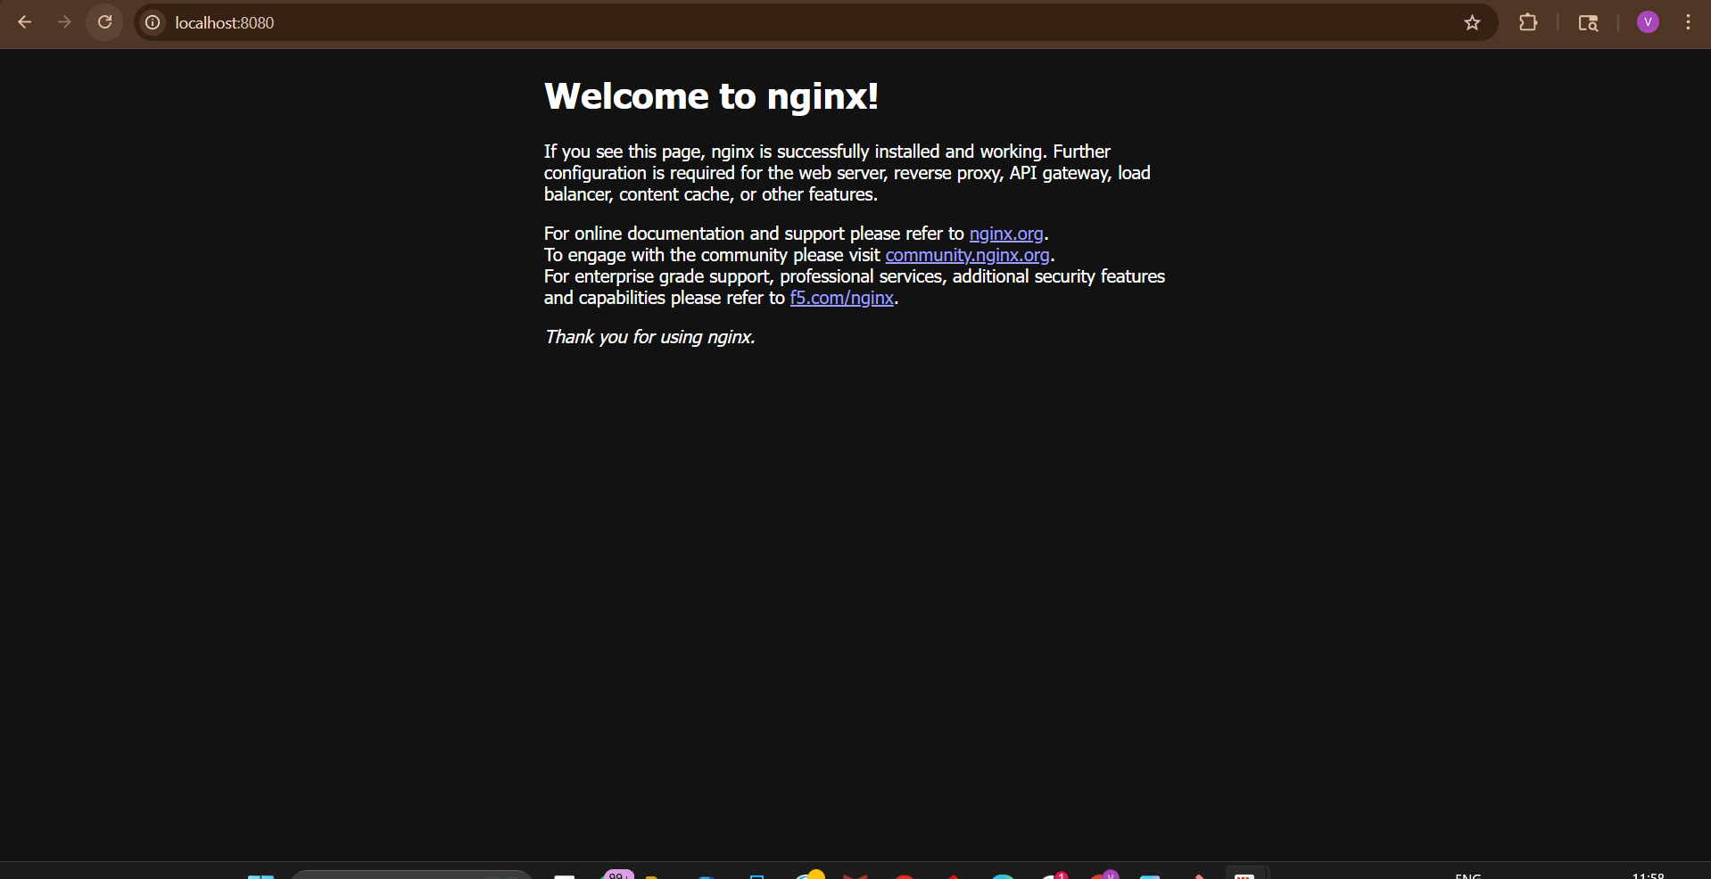

- Set Environment Variables in a Pod Task: Modify the YAML file to includeenvironment variables myname: sabair and City: Hyderabad. Deploy the Pod and use kubectl exec <pod_name> -- env to check if the environment variables are set properly.
  - Create YAML file with Environment Variables
Create a file named pod-env.yaml

apiVersion: v1
kind: Pod
metadata:
name: firstpod
spec:
containers:
- name: nginx-container
image: nginx
env:
- name: myname
value: "sabair"
- name: City
value: "Hyderabad"
  - Create the Pod
Run this command:
kubectl apply -f pod-env.yaml
  - Verify Pod is Running
kubectl get pods
You should see:
firstpod Running
  - Check Environment Variables inside Pod
Run:
kubectl exec firstpod – env
  - Expected Output (Important Lines)
Look for these lines in output:
myname=sabair
City=Hyderabad
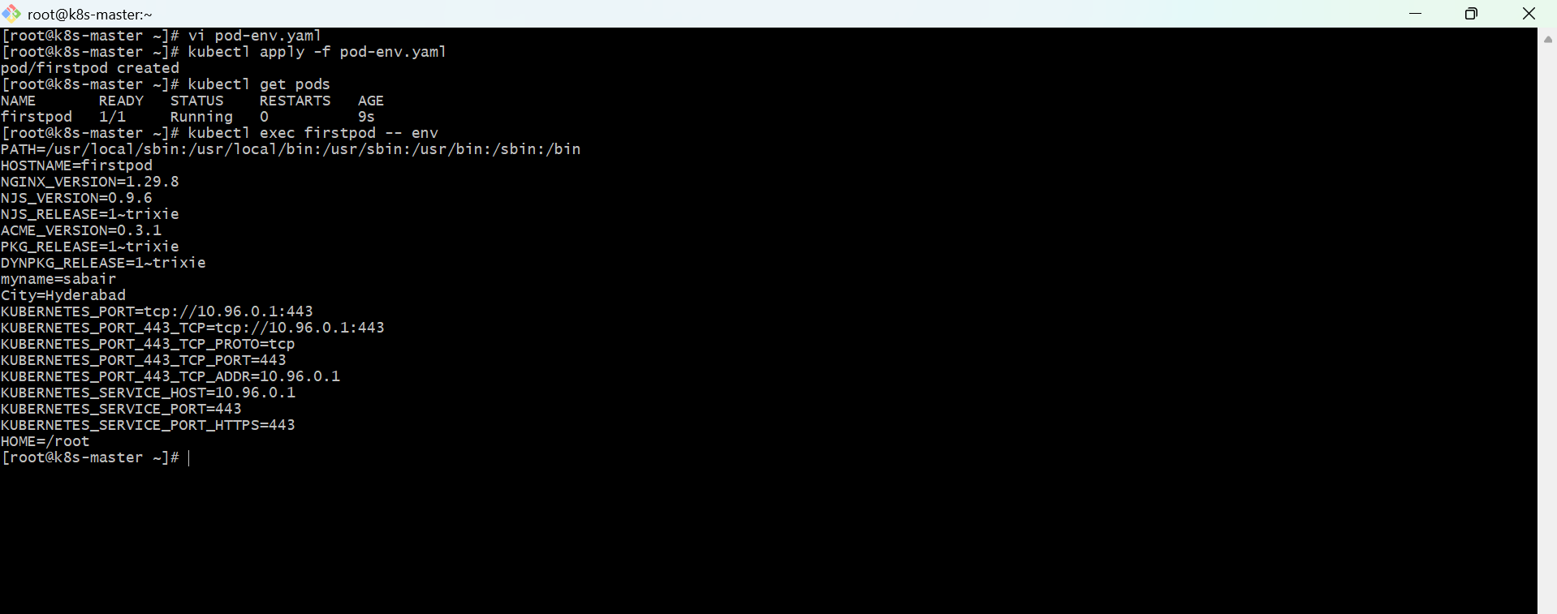

- Deploy a Pod with Commands (Args) in YAML Task: Modify the YAML file to add args that instruct the container to sleep for 50 seconds. Deploy the Pod and use kubectl describe pod to verify the args are correctly passed to the container.
  - Create a file called sleep-pod.yaml
apiVersion: v1
kind: Pod
metadata:
name: sleep-pod
spec:
containers:
- name: sleep-container
image: busybox
command: ["sleep"]
args: ["50"]
  - Deploy the Pod
kubectl apply -f sleep-pod.yaml
  - Verify Pod is created
kubectl get pods
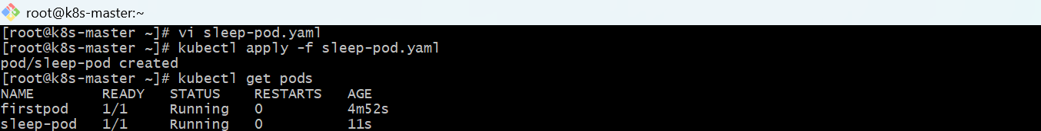
  - Describe the Pod (IMPORTANT step)
kubectl describe pod sleep-pod
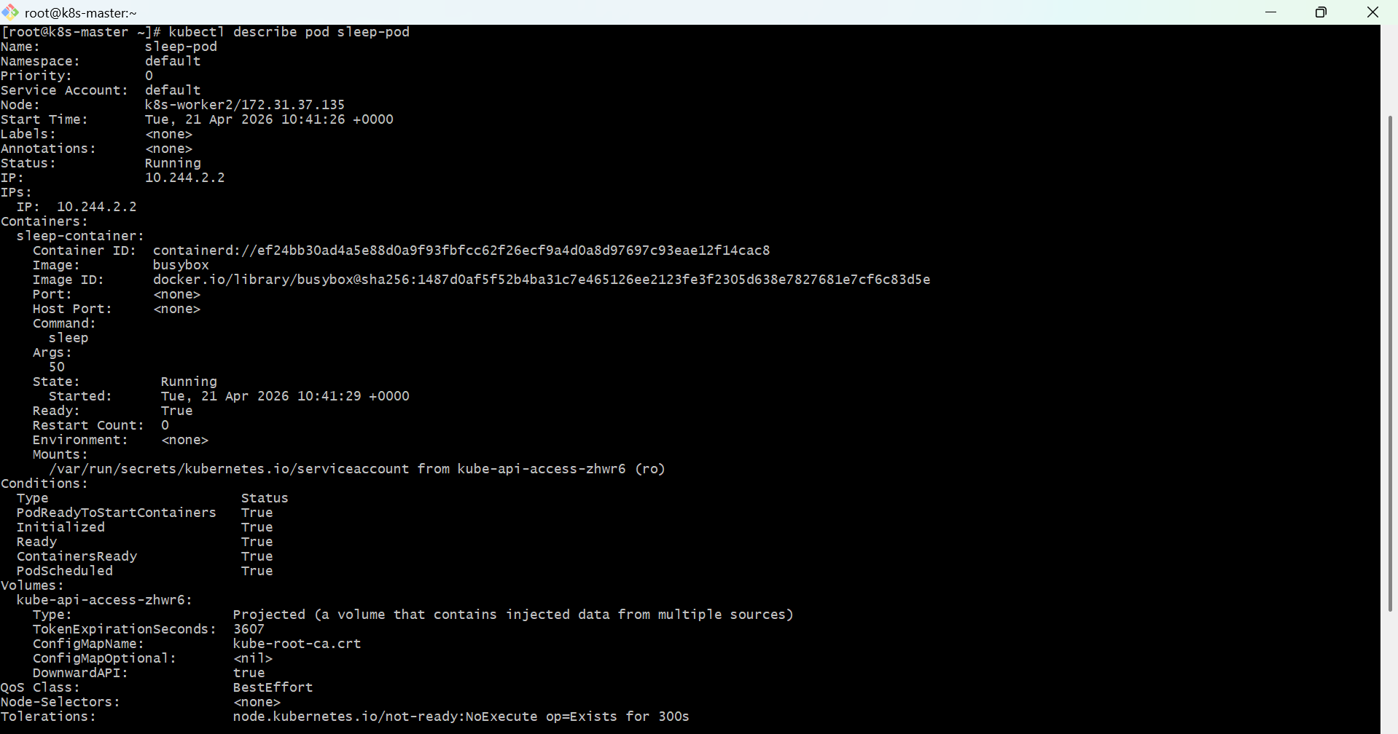
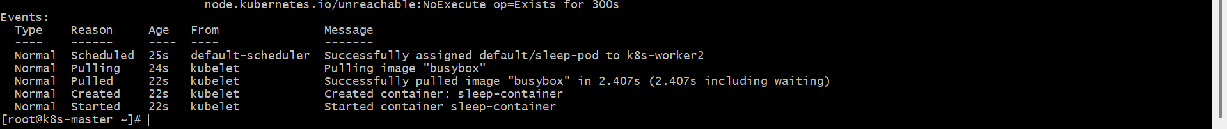
  - Check args in output
In the output, look for this section:
Containers:
sleep-container:
Image: busybox
Command:
sleep
Args:
50
- Create a Pod with Two Containers Task: Create a YAML file to define a Pod with two nginx containers inside. Use kubectl exec to access both containers and verify that both containers can communicate through the same network (e.g., using telnet between them).
  - Create YAML file (2 containers in one Pod)
Create file:
vi twocontainer-pod.yaml
apiVersion: v1
kind: Pod
metadata:
name: twocontainer-pod
labels:
app: nginx-test
spec:
containers:
- name: nginx
image: nginx
- name: busybox
image: busybox
command: ["sleep", "3600"]
  - Apply again
kubectl delete pod twocontainer-pod
kubectl apply -f twocontainer-pod.yaml
kubectl get pods
Expected:
2/2 Running
  - Test communication
Exec into busybox:
kubectl exec -it twocontainer-pod -c busybox -- sh
Run:
wget -qO- http://127.0.0.1
Output = nginx HTML page
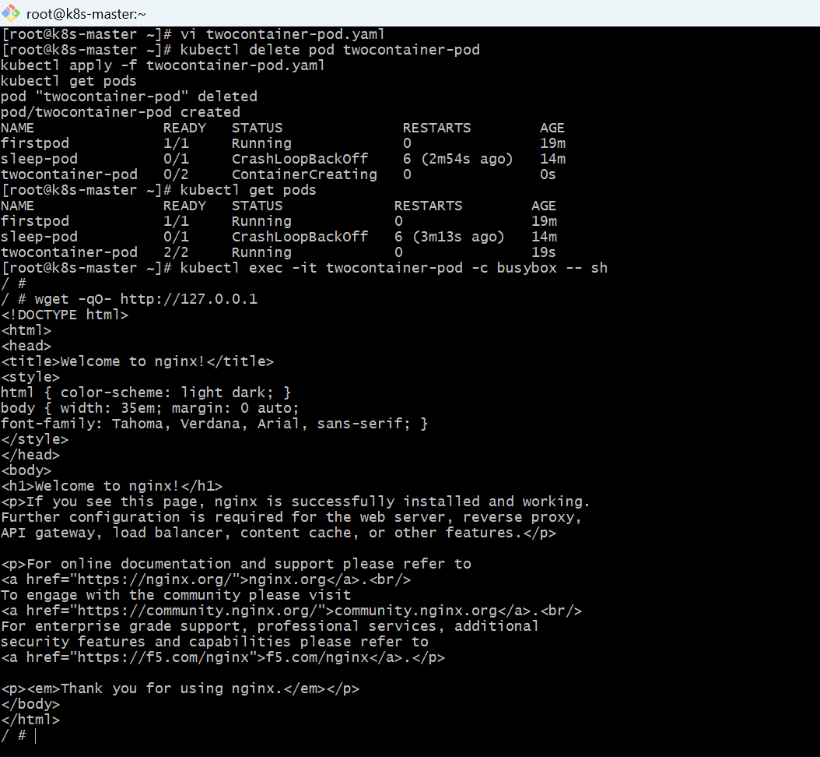

- Set Up an Init Container in a Pod Task: Modify the YAML to include an init container that sleeps for 30 seconds before the main containers start. Verify the init container's execution using kubectl describe pod and check the logs to confirm its completion.
  - YAML File: init-container-pod.yaml
vi init-container-pod.yaml
apiVersion: v1
kind: Pod
metadata:
name: init-pod
spec:
initContainers:
- name: init-sleep
image: busybox
command: ['sh', '-c', 'echo "Init container started"; sleep 30; echo "Init container completed"']
containers:
- name: nginx-container
image: nginx
ports:
- containerPort: 80
  - Create Pod
kubectl apply -f init-container-pod.yaml
  - Check Pod Status
kubectl get pods
Initially you will see:
init-pod 0/1 Init:0/1
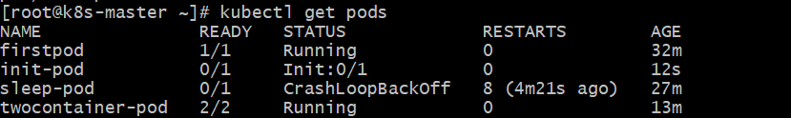
After 30 seconds:
init-pod 1/1 Running
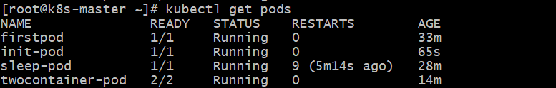
  - Verify Init Container Execution
kubectl describe pod init-pod
Look for section:
Init Containers:
init-sleep:
State: Terminated
Reason: Completed
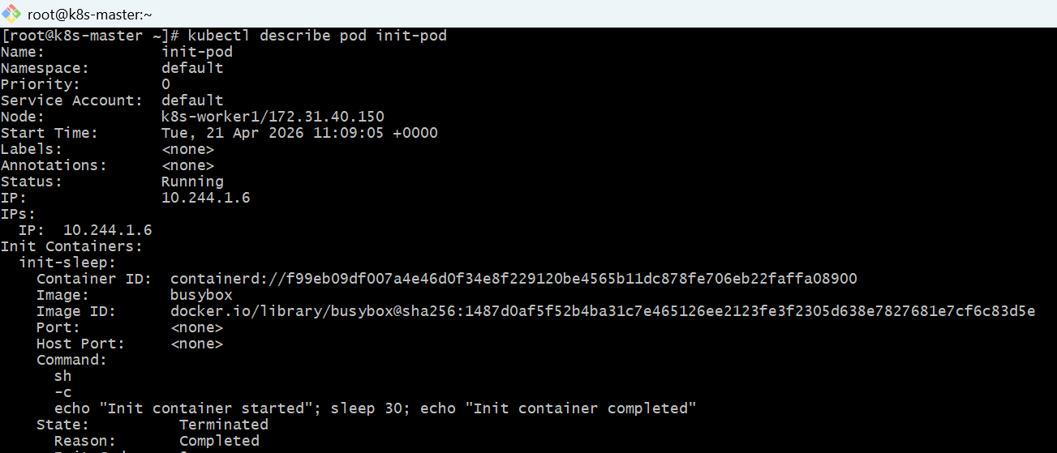
  - Check Init Container Logs
kubectl logs init-pod -c init-sleep
Output:
Init container started
Init container completed
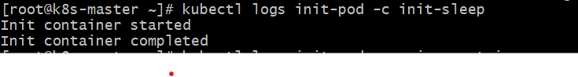
  - Check Main Container Logs (Optional)
kubectl logs init-pod -c nginx-container
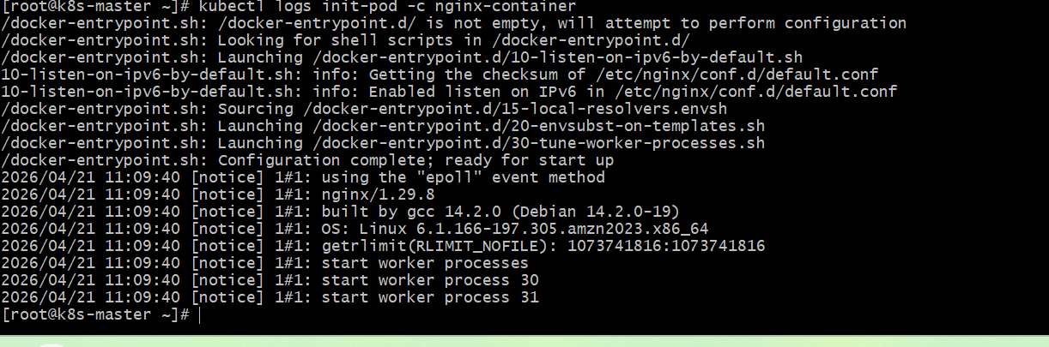

- Run a Dry Run Command to Generate YAML Task: Use the kubectl run nginx --image=nginx --dry-run=client -o yaml command to generate a Pod YAML definition. Modify the generated YAML to suit specific requirements (e.g., labels or environment variables) and deploy it.
  - Generate YAML using dry run
Run this command:
kubectl run nginx --image=nginx --dry-run=client -o yaml > nginx-pod.yaml
This will create a file called nginx-pod.yaml
  - Edit the YAML file
Open the file:
vi nginx-pod.yaml
Modify it like this (added labels + environment variables)
apiVersion: v1
kind: Pod
metadata:
name: nginx
labels:
app: web
env: dev
spec:
containers:
- name: nginx
image: nginx
ports:
- containerPort: 80
env:
- name: myname
value: naseerbaba
- name: city
value: Hyderabad
  - Deploy the Pod
kubectl apply -f nginx-pod.yaml
  - Verify Pod
kubectl get pods
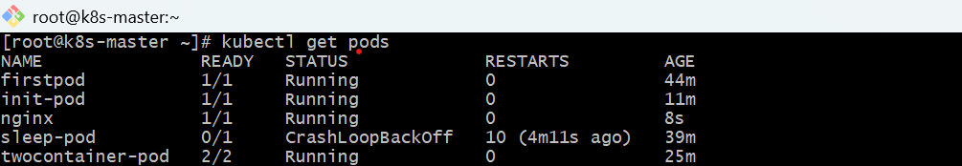
  - Check Labels
kubectl get pod nginx --show-labels
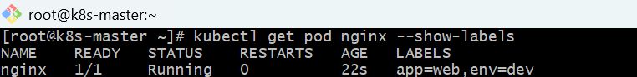
  - Check Environment Variables
kubectl exec nginx -- env
You should see:
myname=naeerbaba
city=Hyderabad
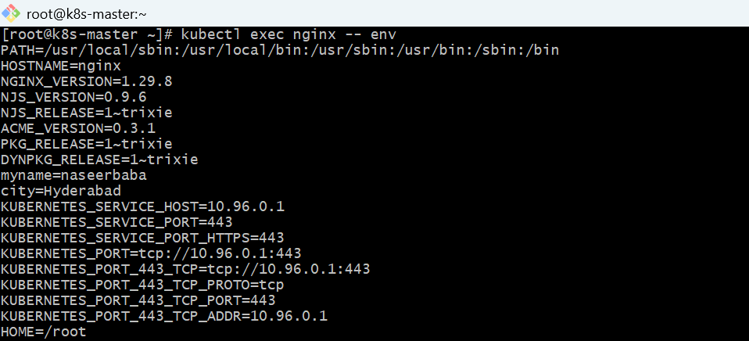

  - Describe Pod (optional)
kubectl describe pod nginx
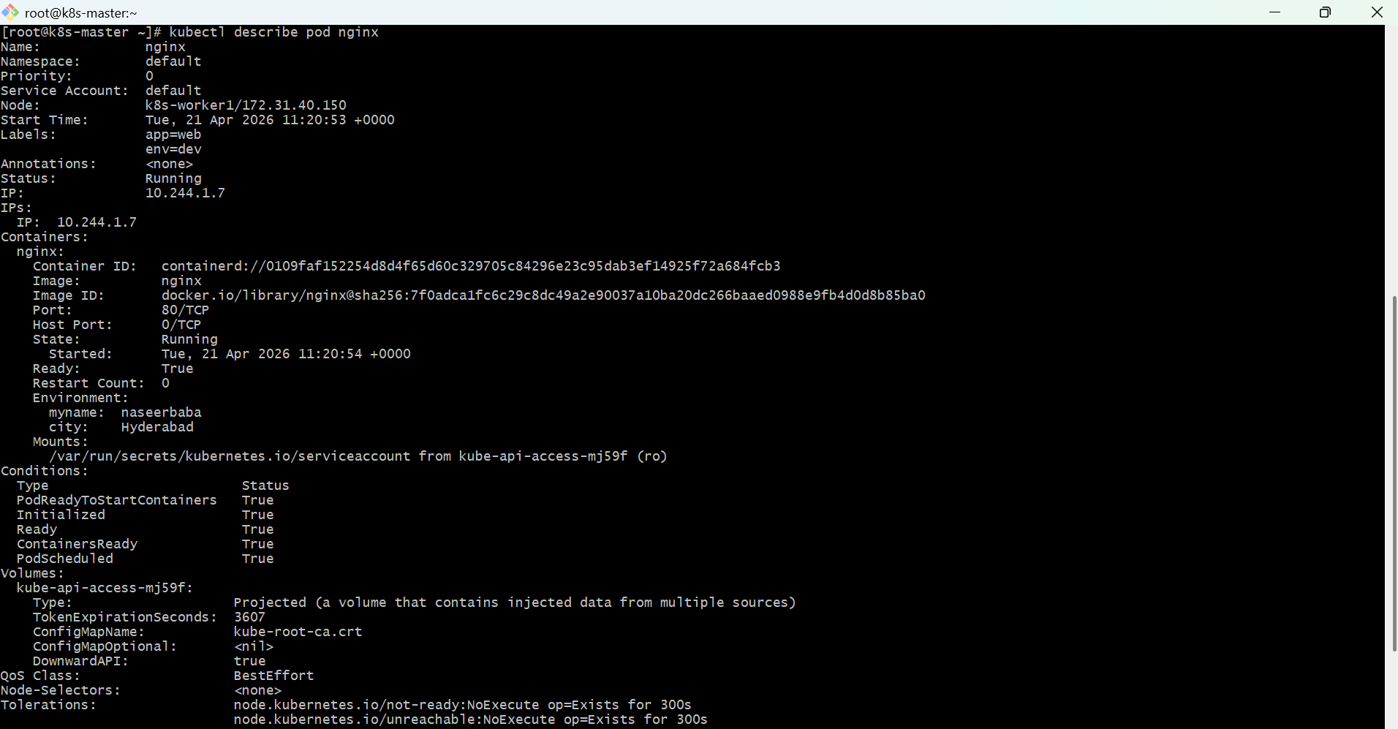
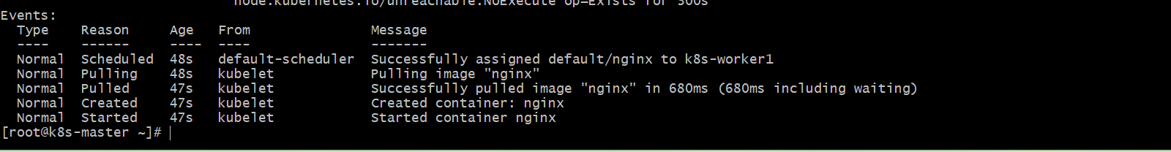

- Use kubectl apply vs kubectl create Task: Create a YAML file to define a Pod. First, deploy it using kubectl create -f <file_name>.yml and then modify the YAML (e.g., change the image version). Use kubectl apply to redeploy and verify the difference between both commands.
  - Create YAML File
Create a file named mypod.yaml

apiVersion: v1
kind: Pod
metadata:
name: mypod
labels:
app: demo
spec:
containers:
- name: nginx-container
image: nginx:1.25
ports:
- containerPort: 80
  - Deploy using kubectl create
kubectl create -f mypod.yaml
Verify:
kubectl get pods
kubectl describe pod mypod
Output will show:
image: nginx:1.25
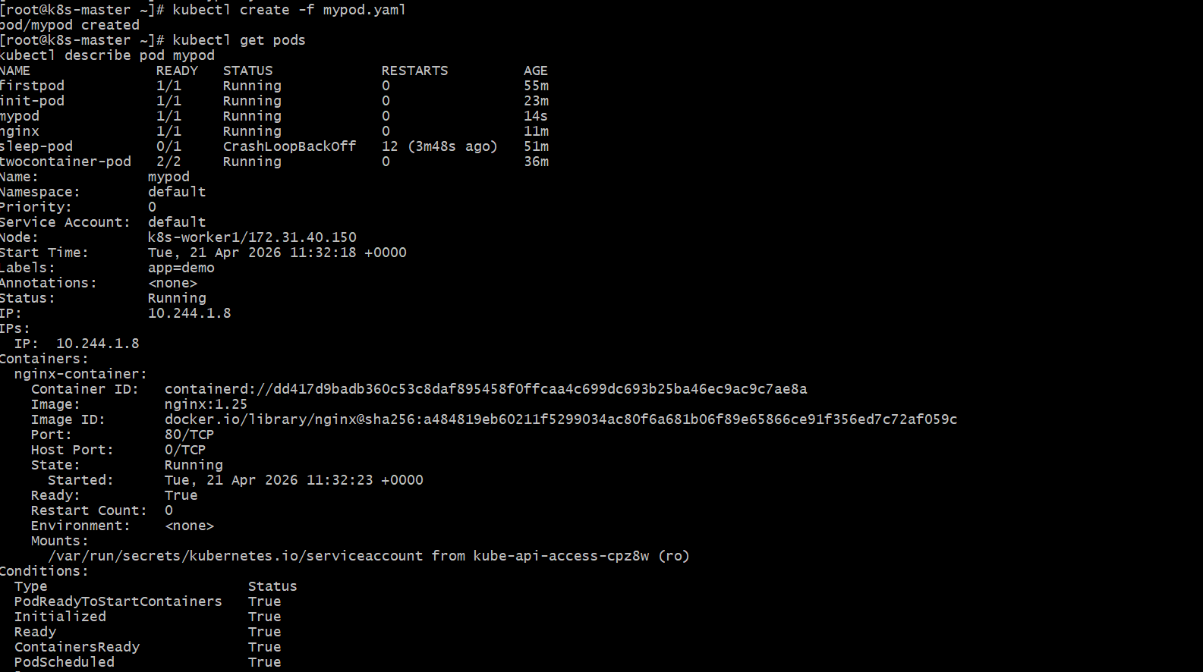
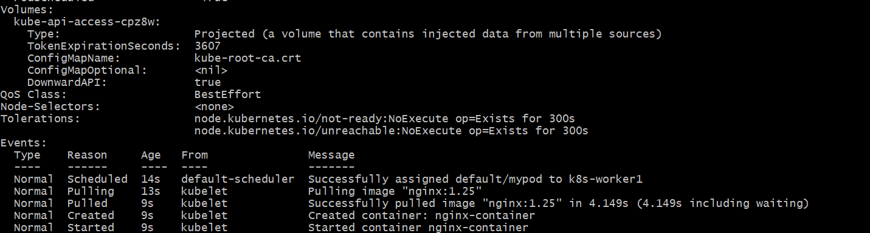
  - Modify YAML
Edit mypod.yaml and change image version:
image: nginx:1.26
apiVersion: v1
kind: Pod
metadata:
name: mypod
labels:
app: demo
spec:
containers:
- name: nginx-container
image: nginx:1.26
ports:
- containerPort: 80
Apply changes using kubectl apply
kubectl apply -f mypod.yaml
  - Verify update
kubectl describe pod mypod | grep Image
Output:
Image: nginx:1.26
- Edit an Existing Pod Configuration Task: Use kubectl edit pod <pod_name> to modify the running Pod's environment variables or image. After making the changes, verify if they took effect by checking the container logs or environment variables using kubectl exec.
  - Edit Existing Pod
  - Check your pod
kubectl get pods
Example output:
firstpod Running
  - Edit the pod
kubectl edit pod firstpod
This opens the YAML in an editor.
  - Try modifying (example)
Add environment variable
Find containers section and modify like this:
containers:
- name: nginx
image: nginx
env:
- name: myname
value: sabair
- name: City
value: Hyderabad
  - Save and exit
- Press Esc
- Type :wq and press Enter (for vi editor)
  - Verify changes
Check environment variables:
kubectl exec firstpod – env
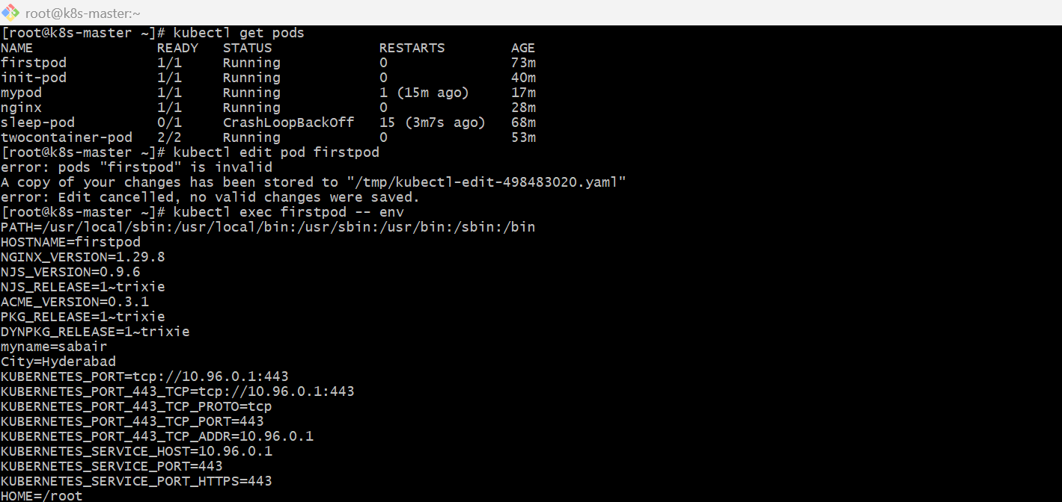
  - Check logs (optional)
kubectl logs firstpod
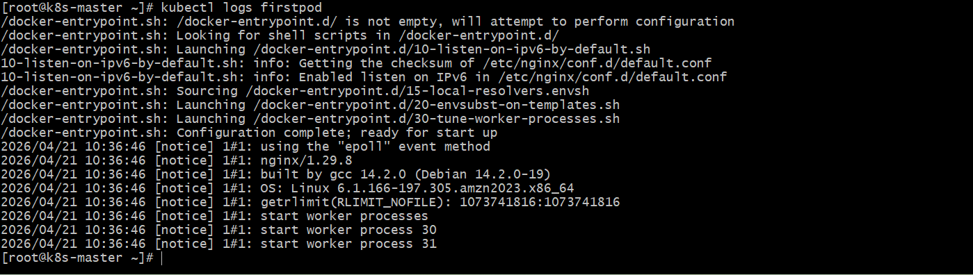

- Expose a Pod Using a Service Task: Create a YAML file to expose your firstpod using a Service (ClusterIP). Ensure that your service is exposing the Pod on port 80 and verify it using kubectl get svc.
  - Create again from YAML
kubectl apply -f firstpod.yaml
  - Check labels
kubectl get pod firstpod --show-labels
Now it should show something like:
app=myapp
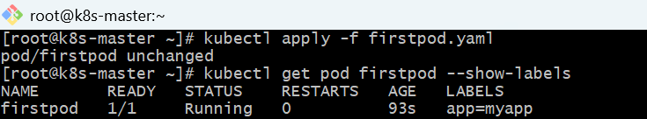
  - Correct firstpod.yaml
Use this:
apiVersion: v1
kind: Pod
metadata:
name: firstpod
labels:
app: myapp
spec:
containers:
- name: nginx
image: nginx
ports:
- containerPort: 80
env:
- name: myname
value: "sabair"
- name: City
value: "Hyderabad"
  - Then create Service YAML
Create service.yaml:
apiVersion: v1
kind: Service
metadata:
name: firstpod-service
spec:
type: ClusterIP
selector:
app: myapp
ports:
- protocol: TCP
port: 80
targetPort: 80
Apply it:
kubectl apply -f service.yaml
Check service:
kubectl get svc
You should see output like:
NAME TYPE CLUSTER-IP PORT(S)
firstpod-service ClusterIP 10.x.x.x 80/TCP
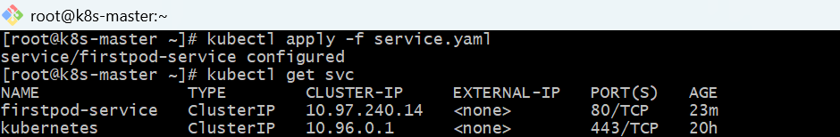
  - Verify Service is connected to Pod
kubectl describe svc firstpod-service
Check this line:
Endpoints: 10.x.x.x:80
If Endpoints = <none>, then label mismatch ❌
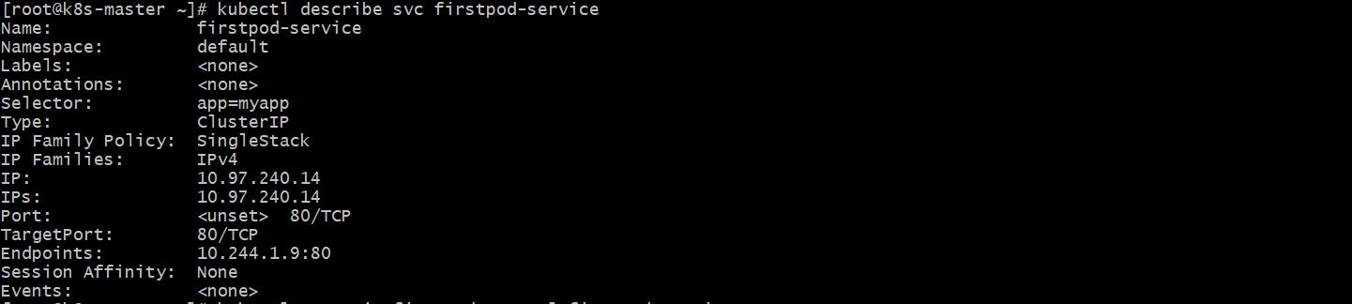
  - Test Service (inside cluster)
kubectl exec -it firstpod -- curl firstpod-service
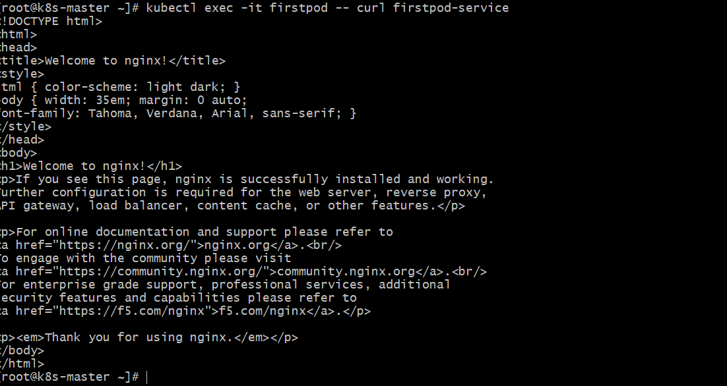

- Pod with Resource Limits and Requests Task: Add resource requests and limits to the containers in your YAML file. Specify CPU and memory requests/limits for both containers and deploy the Pod. Use kubectl describe pod to verify if the resource configurations are correctly applied.
  - YAML File (Pod with Resource Requests & Limits)
Create file: resource-pod.yaml
apiVersion: v1
kind: Pod
metadata:
name: resource-pod
spec:
containers:
- name: nginx-container-1
image: nginx
resources:
requests:
memory: "64Mi"
cpu: "250m"
limits:
memory: "128Mi"
cpu: "500m"
- name: nginx-container-2
image: nginx
resources:
requests:
memory: "128Mi"
cpu: "300m"
limits:
memory: "256Mi"
cpu: "700m"
  - Deploy the Pod
kubectl apply -f resource-pod.yaml
  - Verify Pod is Running
kubectl get pods
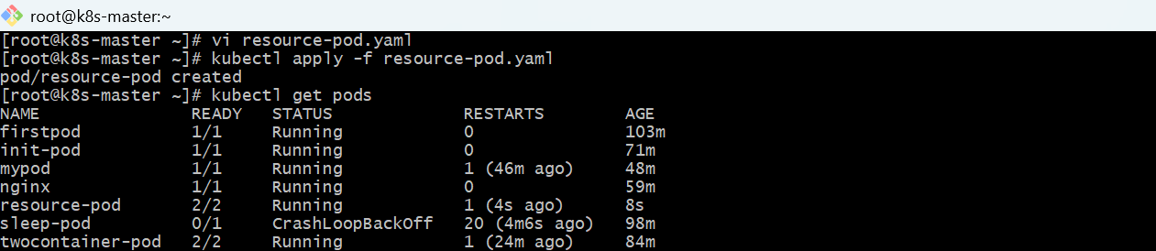
  - Check Resource Configuration
kubectl describe pod resource-pod
  - Expected Output (Important Section)
In the output, look for Containers section:
Containers:
nginx-container-1:
Requests:
cpu: 250m
memory: 64Mi
Limits:
cpu: 500m
memory: 128Mi
nginx-container-2:
Requests:
cpu: 300m
memory: 128Mi
Limits:
cpu: 700m
memory: 256Mi
